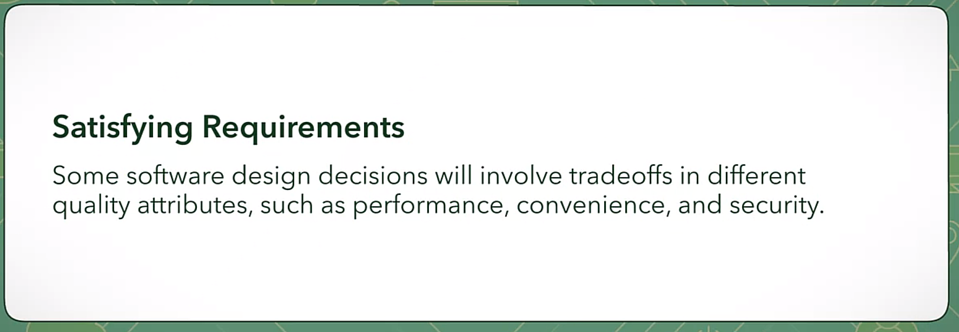

Trade-offs

* Security
* Code quality
* Usability
* Performance
* Scalability
* Maintainability

All vs: **Time to Market**



* Context is important to determine what choice of solution is right for the balance of qualities. –
  + For example, a home located in a low crime area will require different security needs from one located in a high crime area.
  + For software, talking to its stakeholders will help you to understand the context. Sometimes choices made in your software designs can have unintended consequences.



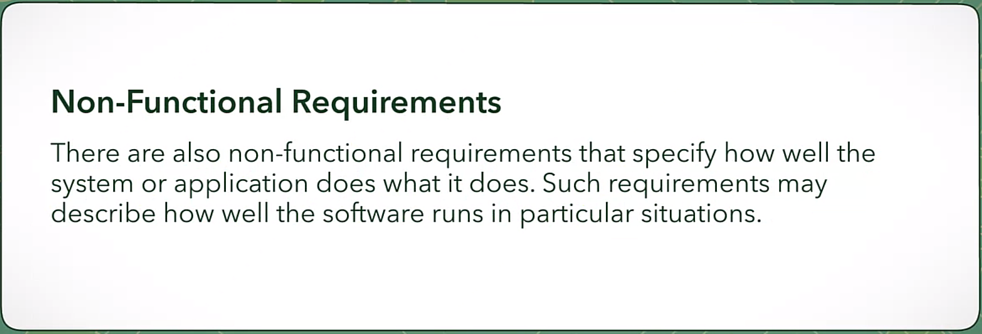

* Commonly
  + Code quality
  + Scalability
  + Maintainability